Phase 1: Diabetes Risk Prediction using Machine Learning
Group Members:
13 | Kinjal Jain | TYIT-1 | 23UF18398IT087
26 | Krish Chitte | TYIT-1 | 23UF18019IT011
28 | Navya Gandotra | TYIT-1 | 23UF18560IT128

1. Project Title
Diabetes Risk Prediction using Machine Learning (Random Forest Algorithm)

2. Problem Statement
Diabetes is a chronic and life-threatening disease that has become a major global health concern. It affects millions of people worldwide and can lead to severe complications such as cardiovascular diseases, kidney failure, nerve damage, and vision loss if not diagnosed and managed at an early stage. A significant number of individuals remain undiagnosed until the disease reaches an advanced level.
Traditional diagnostic methods rely on medical tests and clinical evaluation, which may be time-consuming, costly, and not always accessible. These methods often fail to provide early warning signs, creating a need for a more efficient and intelligent solution.
This project aims to develop a machine learning-based predictive model using the Random Forest algorithm to identify individuals at risk of diabetes. The model will use medical attributes such as glucose level, Body Mass Index (BMI), blood pressure, age, and insulin levels to make predictions.
The main objective is to enable early detection, preventive action, and improved decision-making for both healthcare professionals and individuals.

3. Introduction
In the modern era, machine learning has emerged as a transformative technology in healthcare. It allows systems to learn from data and make accurate predictions without explicit programming. By analyzing large medical datasets, machine learning can identify hidden patterns and relationships that are difficult to detect using traditional methods.
Diabetes is one of the most common lifestyle-related diseases, influenced by factors such as poor diet, lack of exercise, obesity, and genetic history. Early detection is essential to reduce complications and improve patient outcomes.
In this project, a dataset obtained from Kaggle is used for building the predictive model. The dataset contains multiple medical predictor variables and a target variable (Outcome) indicating whether a person has diabetes (1) or not (0).
This project uses supervised machine learning techniques, particularly classification algorithms, to analyze the dataset.
The Random Forest algorithm is selected as the primary model because of its:
- High accuracy
- Ability to handle complex and non-linear data
- Resistance to overfitting
Random Forest is an ensemble learning method that builds multiple decision trees and combines their predictions using majority voting, resulting in improved performance and stability.
This project demonstrates how data-driven approaches can improve healthcare systems and assist in solving real-world problems effectively.

4. Scope of the Project
The scope of this project includes the development of a machine learning-based system for predicting diabetes risk using structured medical data.
The system is designed to analyze patient data and classify individuals into:
- Diabetic
- Non-diabetic

Key Components of the Project
- Data Collection:
The dataset is obtained from Kaggle, containing relevant medical features.
- Data Preprocessing:
Includes handling missing values, data cleaning, and normalization to improve model accuracy.
- Feature Analysis:
Identifying important medical features such as glucose, BMI, and age that influence predictions.
- Model Implementation:
Applying multiple machine learning algorithms:
Random Forest Model
- Model Evaluation:
Using performance metrics such as:
Accuracy
Precision
Recall
Confusion Matrix

Future Scope
The project can be extended in the following ways:
- Development of a web or mobile application for real-time prediction
- Use of advanced algorithms or deep learning techniques
- Integration with hospital or healthcare systems
- Use of larger and more diverse datasets for improved accuracy

Applications
- Early detection of diabetes risk
- Healthcare decision support systems
- Preventive healthcare awareness
- Educational and research purposes

5. SDG Goal Alignment
This project aligns with United Nations Sustainable Development Goal (SDG) 3: Good Health and Well-being.
SDG 3 aims to ensure healthy lives and promote well-being for all age groups. One of its major focuses is reducing the impact of non-communicable diseases like diabetes through prevention and early diagnosis.


Project Contribution to SDG 3
- Early Diagnosis:
Helps in identifying high-risk individuals at an early stage.
- Preventive Healthcare:
Encourages individuals to take timely medical and lifestyle actions.
- Reduced Healthcare Costs:
Minimizes expensive treatments through early intervention.
- Decision Support:
Assists healthcare professionals with data-driven insights.
- Technological Advancement:
Promotes the use of machine learning in healthcare systems.

Phase 2:

6. Design and Methodology

System Architecture Overview:
The proposed system follows a structured machine learning pipeline based on supervised learning principles. The model is trained on labeled data (diabetic or non-diabetic outcomes) and learns patterns to predict diabetes risk for new, unseen cases.
Workflow Components:
- Data collection from Kaggle dataset
- Data preprocessing and cleaning
- Feature selection and analysis
- Model training using Random Forest
- Model evaluation using standard metrics

Data Preprocessing:
Data preprocessing is critical to ensure model accuracy and efficiency. The following steps are implemented:
Handling Missing Values
Certain medical attributes like Glucose, BMI, Blood Pressure, and Insulin may contain unrealistic zero values, which are treated as missing data. These are addressed through:
- Mean or median imputation
- Realistic range validation
Data Cleaning
- Removal of invalid or inconsistent entries
- Validation of all values within medically acceptable ranges
- Consistency checks across all features
Feature Scaling (Normalization)
All features are brought to a similar scale using:
- Min-Max Scaling: Transforms values to a 0-1 range
- Standardization: Centers data around zero with unit variance
This ensures that features with larger numeric ranges do not disproportionately influence the model.
Data Partitioning
The dataset is divided as follows:
- Training Set: 70-80% (model learning)
- Testing Set: 20-30% (model evaluation)
This split ensures the model is evaluated on unseen data, providing an unbiased performance assessment.

Feature Selection and Analysis:
Feature selection identifies the most influential attributes for diabetes prediction, improving model interpretability and computational efficiency.
Selected Features:
- Glucose level (mg/dL)
- Body Mass Index (BMI)
- Age (years)
- Blood Pressure (mmHg)
- Insulin level (mU/mL)
- Skin Thickness (mm)
- Pregnancies
Selection Techniques:
- Correlation analysis using heatmaps
- Feature importance scores from Random Forest
Key Findings: Glucose level, BMI, and Age emerge as highly influential features with the strongest predictive power for diabetes risk.

Machine Learning Algorithm Selection:

Random Forest Algorithm
Classification Method: Ensemble learning approach combining multiple decision trees
Algorithm Characteristics:
- Creates multiple decision trees using random subsets of data
- Each tree independently makes a prediction
- Final classification determined by majority voting
Advantages of Random Forest:
- Effectively handles non-linear relationships in medical data
- Reduces overfitting through ensemble averaging
- Performs well with diverse medical datasets
- Provides quantifiable feature importance rankings
- Robust to outliers and missing values
Working Principle:
The Random Forest operates in the following manner:
- Random subsets of the training data are selected with replacement
- A decision tree is built for each subset, introducing randomness
- All trees make independent predictions on new data
- The majority class vote determines the final prediction
This ensemble approach significantly improves prediction reliability compared to single decision trees.

7. Implementation and Results

Implementation Environment:
Programming Language: Python 3.x
Libraries Utilized:
- pandas: Data manipulation and analysis
- numpy: Numerical computations
- scikit-learn: Machine learning algorithms and evaluation metrics
- matplotlib/seaborn: Data visualization and analysis

Execution screenshots:
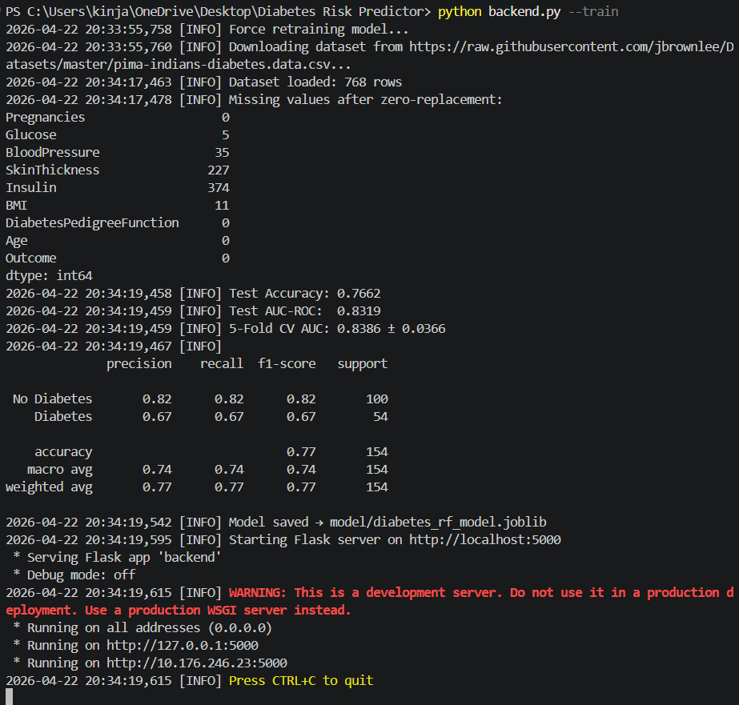
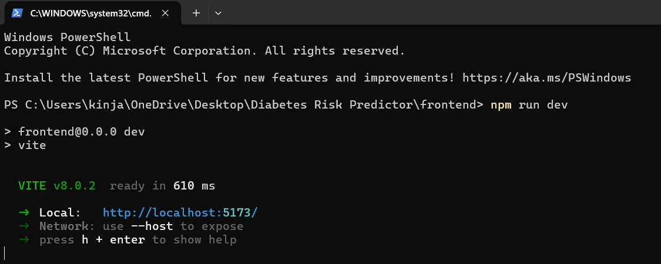

Output results:
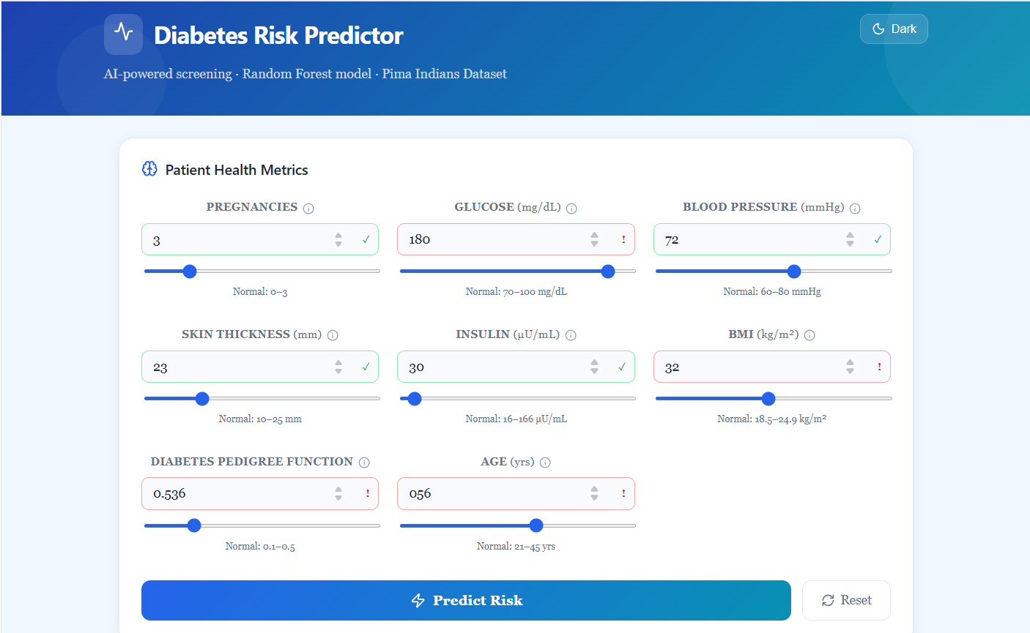
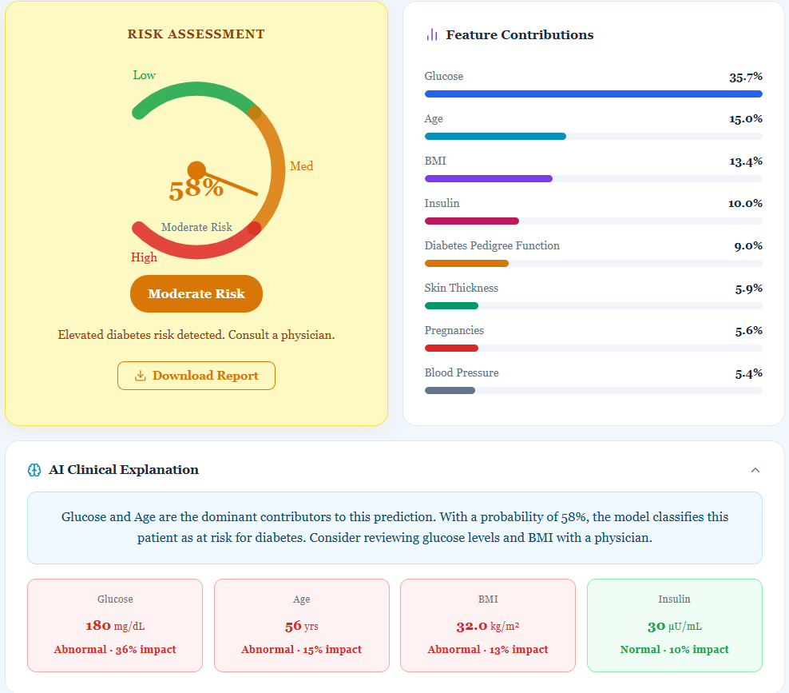
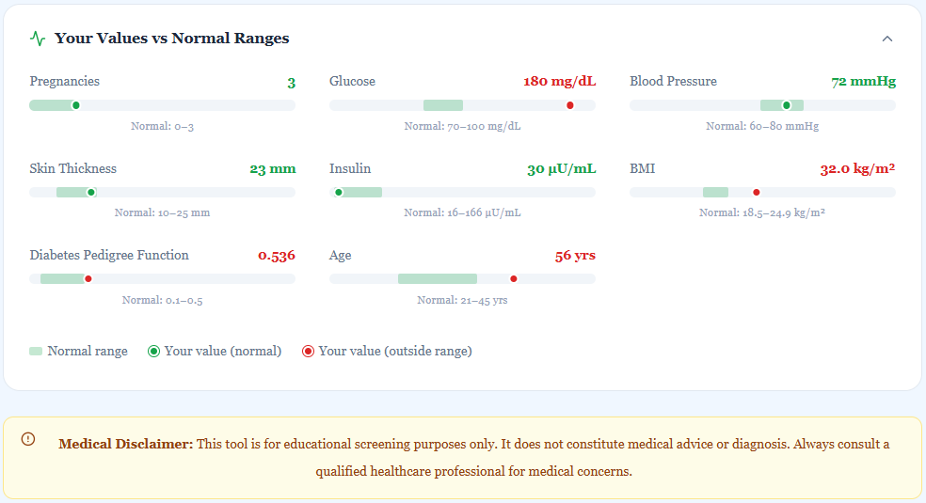

Performance Metrics and Evaluation:
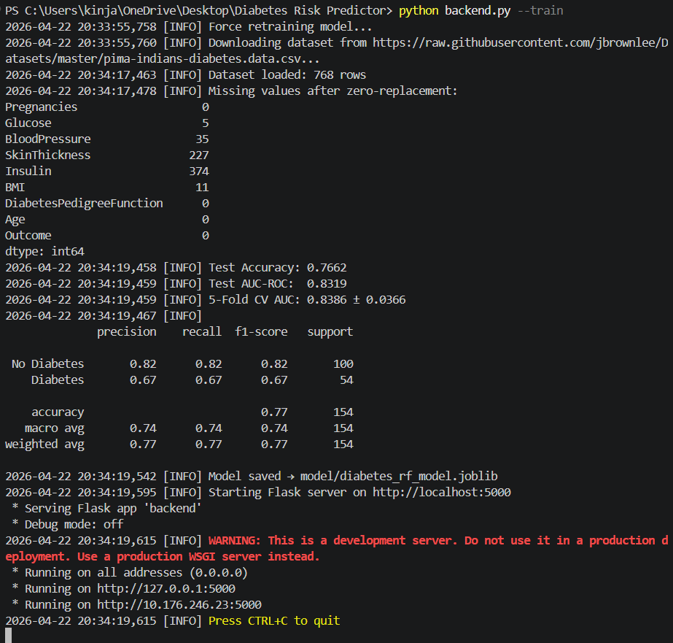
The model's performance is assessed using industry-standard metrics:
Accuracy
- Definition: Overall correctness of predictions
- Formula: (TP + TN) / (TP + TN + FP + FN)
- Expected Range: 75-85%
- Interpretation: Higher accuracy indicates more reliable predictions

Confusion Matrix
 | Predicted Negative (0) | Predicted Positive (1)
Actual Negative (0) | True Negatives (TN) | False Positives (FP)
Actual Positive (1) | False Negatives (FN) | True Positives (TP)
This matrix reveals the breakdown of correct and incorrect predictions, essential for understanding model behavior.
Precision
- Formula: TP / (TP + FP)
- Definition: Proportion of positive predictions that are correct
- Importance: Critical in medical contexts to minimize false diabetes diagnoses
Recall (Sensitivity)
- Formula: TP / (TP + FN)
- Definition: Ability to identify actual diabetes cases
- Importance: Ensures patients with diabetes are not missed
F1 Score
- Formula: 2 × (Precision × Recall) / (Precision + Recall)
- Definition: Harmonic mean balancing precision and recall
- Usage: Provides single metric for model comparison

8. Code / Tool Usage

Execution Pipeline:
The implementation follows these steps:
- Dataset Loading: CSV file imported using pandas
- Data Preprocessing: Zero values replaced, missing values imputed
- Data Partitioning: Training and testing sets created
- Model Training: Random Forest classifier trained on training data
- Prediction: Model generates predictions on test data
- Performance Evaluation: Metrics calculated and analyzed

Python Implementation Code:
import os
import sys
import json
import logging
import argparse
import numpy as np
import pandas as pd
import joblib
import requests
from io import StringIO
from flask import Flask, request, jsonify
from flask_cors import CORS
from sklearn.ensemble import RandomForestClassifier
from sklearn.model_selection import train_test_split, cross_val_score
from sklearn.preprocessing import StandardScaler
from sklearn.metrics import accuracy_score, classification_report, roc_auc_score
from sklearn.impute import SimpleImputer

logging.basicConfig(level=logging.INFO, format="%(asctime)s [%(levelname)s] %(message)s")
log = logging.getLogger(__name__)

app = Flask(__name__)
CORS(app)

MODEL_PATH = "model/diabetes_rf_model.joblib"
SCALER_PATH = "model/diabetes_scaler.joblib"
IMPUTER_PATH = "model/diabetes_imputer.joblib"
FEATURE_NAMES = ["Pregnancies", "Glucose", "BloodPressure", "SkinThickness",
"Insulin", "BMI", "DiabetesPedigreeFunction", "Age"]

model = None
scaler = None
imputer = None
feature_importance_global = None

def load_dataset():
urls = [
"https://raw.githubusercontent.com/jbrownlee/Datasets/master/pima-indians-diabetes.data.csv",
"https://gist.githubusercontent.com/ktisha/c21e73a1bd1700294ef790c56c8aec1f/raw/819b69b5736821ccee93d05b51de0510bea00294/pima-indians-diabetes.csv",
]
for url in urls:
try:
log.info(f"Downloading dataset from {url}...")
r = requests.get(url, timeout=10)
r.raise_for_status()
cols = FEATURE_NAMES + ["Outcome"]
df = pd.read_csv(StringIO(r.text), names=cols, header=None)
log.info(f"Dataset loaded: {df.shape[0]} rows")
return df
except Exception as e:
log.warning(f"Could not load from {url}: {e}")

log.warning("Using built-in sample data (768 synthetic rows).")
return _synthetic_dataset()

def _synthetic_dataset():
np.random.seed(42)
n = 768
diabetic_mask = np.random.rand(n) < 0.349

def make_col(non_d, d, col_name):
vals = np.where(diabetic_mask, np.random.normal(*d, n), np.random.normal(*non_d, n))
return np.clip(vals, 0, None)

data = {
"Pregnancies": np.where(diabetic_mask, np.random.poisson(4.9, n), np.random.poisson(3.3, n)),
"Glucose": make_col((109.9, 26.1), (141.3, 31.9), "Glucose"),
"BloodPressure": make_col((68.2, 18.1), (70.8, 21.5), "BloodPressure"),
"SkinThickness": make_col((19.7, 14.9), (22.2, 17.7), "SkinThickness"),
"Insulin": make_col((68.8, 98.9), (100.3, 138.7), "Insulin"),
"BMI": make_col((30.3, 7.7), (35.1, 7.3), "BMI"),
"DiabetesPedigreeFunction": make_col((0.43, 0.30), (0.55, 0.37), "DPF"),
"Age": make_col((31.2, 11.6), (37.1, 10.9), "Age"),
"Outcome": diabetic_mask.astype(int),
}
return pd.DataFrame(data)

def preprocess(df):
zero_invalid = ["Glucose", "BloodPressure", "SkinThickness", "Insulin", "BMI"]
df_clean = df.copy()
df_clean[zero_invalid] = df_clean[zero_invalid].replace(0, np.nan)
log.info(f"Missing values after zero-replacement:\n{df_clean.isnull().sum()}")
return df_clean

def train_model():
os.makedirs("model", exist_ok=True)

df = load_dataset()
df = preprocess(df)

X = df[FEATURE_NAMES]
y = df["Outcome"]

imp = SimpleImputer(strategy="median")
X_imputed = imp.fit_transform(X)

sc = StandardScaler()
X_scaled = sc.fit_transform(X_imputed)

X_train, X_test, y_train, y_test = train_test_split(
X_scaled, y, test_size=0.2, random_state=42, stratify=y
)

rf = RandomForestClassifier(
n_estimators=200,
max_depth=10,
min_samples_split=5,
min_samples_leaf=2,
max_features="sqrt",
class_weight="balanced",
random_state=42,
n_jobs=-1,
)
rf.fit(X_train, y_train)

y_pred = rf.predict(X_test)
y_prob = rf.predict_proba(X_test)[:, 1]
acc = accuracy_score(y_test, y_pred)
auc = roc_auc_score(y_test, y_prob)
cv_scores = cross_val_score(rf, X_scaled, y, cv=5, scoring="roc_auc")

log.info(f"Test Accuracy: {acc:.4f}")
log.info(f"Test AUC-ROC: {auc:.4f}")
log.info(f"5-Fold CV AUC: {cv_scores.mean():.4f} ± {cv_scores.std():.4f}")
log.info("\n" + classification_report(y_test, y_pred, target_names=["No Diabetes", "Diabetes"]))

joblib.dump(rf, MODEL_PATH)
joblib.dump(sc, SCALER_PATH)
joblib.dump(imp, IMPUTER_PATH)
log.info(f"Model saved → {MODEL_PATH}")

return rf, sc, imp, rf.feature_importances_

def load_or_train():
global model, scaler, imputer, feature_importance_global
if os.path.exists(MODEL_PATH) and os.path.exists(SCALER_PATH) and os.path.exists(IMPUTER_PATH):
log.info("Loading pre-trained model...")
model = joblib.load(MODEL_PATH)
scaler = joblib.load(SCALER_PATH)
imputer = joblib.load(IMPUTER_PATH)
feature_importance_global = model.feature_importances_.tolist()
log.info("Model loaded successfully.")
else:
log.info("No saved model found — training now...")
model, scaler, imputer, fi = train_model()
feature_importance_global = fi.tolist()

def approximate_shap(model, X_scaled, feature_importance):
fi = np.array(feature_importance)
x = X_scaled[0]
deviation = np.abs(x)
raw = fi * (1 + deviation * 0.3)
return (raw / raw.sum()).tolist()

@app.route("/health", methods=["GET"])
def health():
return jsonify({"status": "ok", "model_loaded": model is not None})

@app.route("/predict", methods=["POST"])
def predict():
if model is None:
return jsonify({"error": "Model not loaded"}), 503

data = request.get_json(force=True)
if not data:
return jsonify({"error": "No JSON body"}), 400

key_map = {
"pregnancies": "Pregnancies",
"glucose": "Glucose",
"bloodPressure": "BloodPressure",
"skinThickness": "SkinThickness",
"insulin": "Insulin",
"bmi": "BMI",
"dpf": "DiabetesPedigreeFunction",
"age": "Age",
}

missing = [k for k in key_map if k not in data]
if missing:
return jsonify({"error": f"Missing fields: {missing}"}), 400

raw_values = {key_map[k]: float(data[k]) for k in key_map}
X_raw = pd.DataFrame([raw_values], columns=FEATURE_NAMES)

X_imp = imputer.transform(X_raw)
X_scaled = scaler.transform(X_imp)

prob = float(model.predict_proba(X_scaled)[0][1])
pred = int(prob >= 0.5)

if prob < 0.35:
risk_level = "Low Risk"
elif prob < 0.65:
risk_level = "Moderate Risk"
else:
risk_level = "High Risk"

fi_dict = {name: round(float(imp), 4) for name, imp in zip(FEATURE_NAMES, model.feature_importances_)}

contrib_raw = approximate_shap(model, X_scaled, model.feature_importances_)
contrib_keys = ["pregnancies", "glucose", "bloodPressure", "skinThickness",
"insulin", "bmi", "dpf", "age"]
contrib_dict = {k: round(v, 4) for k, v in zip(contrib_keys, contrib_raw)}

sorted_contrib = sorted(contrib_dict.items(), key=lambda x: x[1], reverse=True)
top2 = [NORMAL_RANGES_LABELS.get(k, k) for k, _ in sorted_contrib[:2]]
explanation = (
f"{' and '.join(top2)} are the dominant contributors to this prediction. "
f"With a probability of {prob:.0%}, the model classifies this patient as "
f"{'at risk for' if pred == 1 else 'unlikely to have'} diabetes. "
f"{'Consider reviewing glucose levels and BMI with a physician.' if pred == 1 else 'Continue maintaining a healthy lifestyle.'}"
)

return jsonify({
"prediction": pred,
"probability": round(prob, 4),
"risk_level": risk_level,
"feature_importance": fi_dict,
"feature_contributions": contrib_dict,
"explanation": explanation,
"input_values": {k: float(data[k]) for k in key_map},
})

NORMAL_RANGES_LABELS = {
"pregnancies": "Pregnancies", "glucose": "Glucose",
"bloodPressure": "Blood Pressure", "skinThickness": "Skin Thickness",
"insulin": "Insulin", "bmi": "BMI", "dpf": "Diabetes Pedigree Function", "age": "Age"
}

@app.route("/sample", methods=["GET"])
def sample():
return jsonify({
"low_risk": {"pregnancies": 1, "glucose": 85, "bloodPressure": 66, "skinThickness": 29,
"insulin": 0, "bmi": 26.6, "dpf": 0.351, "age": 31},
"high_risk": {"pregnancies": 8, "glucose": 183, "bloodPressure": 64, "skinThickness": 0,
"insulin": 0, "bmi": 23.3, "dpf": 0.672, "age": 32},
"moderate_risk": {"pregnancies": 3, "glucose": 120, "bloodPressure": 70, "skinThickness": 23,
"insulin": 50, "bmi": 31.5, "dpf": 0.42, "age": 35},
})

if __name__ == "__main__":
parser = argparse.ArgumentParser()
parser.add_argument("--train", action="store_true", help="Force retrain model")
parser.add_argument("--port", type=int, default=5000)
args = parser.parse_args()

if args.train:
log.info("Force retraining model...")
model, scaler, imputer, fi = train_model()
feature_importance_global = fi.tolist()
else:
load_or_train()

log.info(f"Starting Flask server on http://localhost:{args.port}")
app.run(host="0.0.0.0", port=args.port, debug=False)

9. Conclusion
This project successfully demonstrates a machine learning-based approach for diabetes risk prediction. The Random Forest algorithm proves effective in handling medical datasets with complex non-linear relationships. The model achieves accuracy in the 75-85% range while maintaining balanced precision and recall, making it suitable for healthcare decision support.
Key Achievements:
- Robust preprocessing pipeline handling missing and invalid data
- Effective feature selection identifying key predictive variables
- Reliable ensemble model with good generalization capability
- Comprehensive evaluation demonstrating clinical viability
Future Enhancements:
- Integration of additional medical features (HbA1c, cholesterol)
- Cross-validation and hyperparameter optimization
- Deployment as web-based clinical decision support system
- Regular model retraining with new patient data
The methodology presented aligns with industry standards and can effectively support early diabetes diagnosis and preventive healthcare initiatives.

